Certificate of Analysis – Technical Data sheet

Product name | MAC, Human, mAb B7
Catalog number | HM2443-100UG
Lot number | xxxxxXxxxx-X | Expiry date | MMM YYYY
Volume | 1 ml | Amount | 100 µg
Formulation | 0.2 µm filtered in PBS+0.1%BSA+0.02%NaN3 | Concentration | 100 µg/ml
Host Species | Mouse IgG1k | Conjugate | None
Endotoxin | N.A. | Purification | Protein G
Storage | 4°C
Application notes
 | IHC-F | IHC-P | IF | FC | FS | IA | IP | W
Reference # |  |  |  |  |  | 1,2
Yes | ● | ● | ● |  |  | ● |  | ●
No
N.D. |  |  |  | ● | ● |  | ●

N.D.= Not Determined; IHC = Immuno histochemistry; F = Frozen sections; P = Paraffin sections; IF = Immuno Fluorescence; FC = Flow Cytometry; FS = Functional Studies; IA = Immuno Assays; IP = Immuno Precipitation; W = Western blot
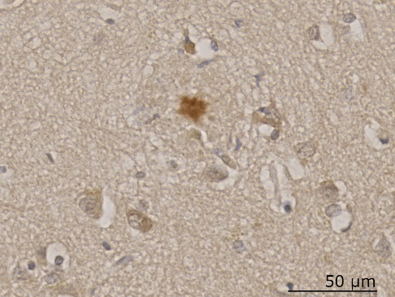 | 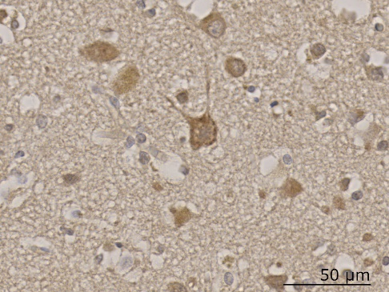 | 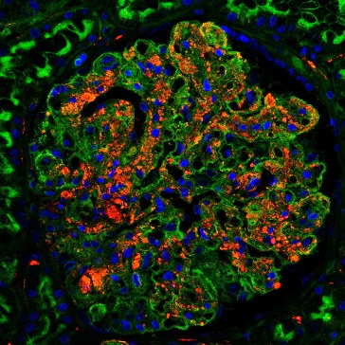
IHC-P: MAC staining using B7 antibody on plaques in FFPE Alzheimer’s brain tissue (Braak stage VI). Image kindly provided by Paul Morgan’s lab, Dementia Research Institute, Cardiff University. | IHC-P: MAC staining using B7 antibody on neurons in FFPE Alzheimer’s brain tissue (Braak stage VI). Image kindly provided by Paul Morgan’s lab, Dementia Research Institute, Cardiff University. | IF: Staining in Duboscq-Brazil fixed, paraffin embedded human kidney sections. B7 antibody is visualized in red using a Cy3-labeled secondary antibody. In addition, wheat germ agglutinin (WGA) is stained with FITC and appears in green, while cell nuclei are stained with DAPI and shown in blue.
Dilutions to be used depend on detection system applied. It is recommended that users test the reagent and determine their own optimal dilutions. The typical starting working dilution is 1:50.
- W: A non-reduced or reduced sample treatment and SDS-Page was used to visualize C9. The band size is 71 kDa.
- IHC-P: Tissue sections were pretreated with a citrate antigen retrieval followed by pepsin (1 mg/ml) and blocked with 0.3% BSA + 15% normal goat serum. B7 staining was used at 10 µg/ml (overnight at 4ºC).
- IF: Antigen retrieval was performed on Duboscq-Brazil fixed, paraffin embedded human kidney sections with buffer pH 6.0, in decloaking chamber. After blocking non-specific sites with 1% BSA, sections were incubated with B7 antibody diluted 1:100 in PBS1x, followed by Cy3-conjugated donkey anti-mouse secondary antibody. Nuclei were stained with DAPI, while renal structures were highlighted with fluorescein wheat-germ agglutinin.
- IA: The B7 antibody (1 µg/ml) was captured overnight at 4ºC in PBS and blocked with 1% BSA + PBS-T. A polyclonal rabbit-anti-human C9 antibody was used as the detection (Ref 1,2).

General Information
Description | The monoclonal B7 antibody (HM2443) recognizes a C9 epitope of the membrane attack complex (MAC). The three distinct activation pathways of complement converge with the formation of a C3 convertase and subsequently C3b. This initiates the formation of the C5 convertase. The cleavage of C5 by this convertase initiates the lytic or terminal pathway. In contrast to the three activation pathways, which require enzymatic cleavage for activation, the terminal pathway relies on conformational changes induced by binding. Binding of C6 to C5b facilitates binding of C7 which alters the conformation of the complex. After binding of C8, a variable number of C9 molecules associates to the C5b-8 complex to form C5b-9, which is also termed as MAC. The formation of MAC causes lysis of cells when the incorporated C9 molecules of the complex unite into a pore-forming structure. The B7 antibody can be used to stain C5b-9 (or MAC) deposition in tissues and can recognize both C9 and soluble C5b-9 (sC5b-9/TCC) in fluid-phase matrices, like serum or plasma.
Aliases | Membrane attack complex, Terminal complement complex, C5b-9 complex.
Cross reactivity | The antibody is cross-reactive to human C9 and to rat C9/C5b-9.
References | - Zelek WM, et Al. Cerebrospinal fluid complement system biomarkers in demyelinating disease, 2020. Mult Scler. Dec;26(14):1929-1937.  - McMahon O, et Al. The rare C9 P167S risk variant for age-related macular degeneration increases polymerization of the terminal component of the complement cascade, 2021. Hum Mol Genet. Jun 17;30(13):1188-1199.
Storage&stability | Product should be stored at 4°C. Under recommended storage conditions, product is stable for at least one year.
Precautions | For research use only. Not for use in or on humans or animals or for diagnostics. It is the responsibility of the user to comply with all local/state and federal rules in the use of this product. Hycult Biotech is not responsible for any patent infringements that might result from the use or derivation of this product.

We hereby certify that the above-stated information is correct and that this product has been successfully tested by the Quality Control Department. This product was released for sale according to the existing specifications. This document has been produced electronically and is valid without a signature.
Approved by Manager of QC
Date

Do you have any questions or comments regarding this product? Please contact us via support@hycultbiotech.com.

